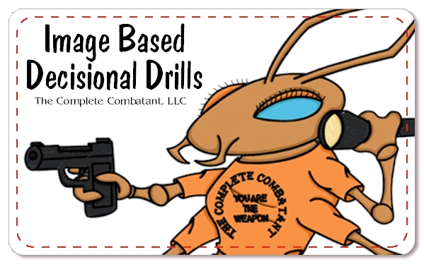 |  | IBDD Suggestions
CLASS LOCATION:  _______________________________________________________________________________________________________________  CONTACT INFORMATION:  _______________________________________________________________________________________________________________  ASSISTANTs: __________________  _____________________________________  STUDENT LIST: _________________  IBDD DRY PRACTICE: __________  IBDD LIVE FIRE: ________________  - TABLE START____________  - FROM HOLSTER_________  CONFIRMATIONS SENT:  HOST: __________________  - STUDENTS: ______________  rEGISTRATION & WAIVERS COMPLETED: __________________  MEDICAL PROTOCOL/MEDICAL KIT: __________________________  FOLLOW UP EMAIL AFTER CLASS SENT: _________________________ |  | THIS PAGE IS FULL OF SUGGESTIONS. MIX AND MATCH. SEE WHAT IS APPLICABLE AND WHAT WORKS FOR YOU.  _____IBDD Image Cards (original deck & expansion packs)  _____SIRT Training Pistol  _____BlueGun  _____GLOCK AirSoft  _____Paper Targets for AirSoft  _____Firearm, gear, etc.  _____Targets for Live Fire (humanoid)  _____The Dude target for OC accuracy  _____Pasters (live fire)  _____Timer  _____Inert OC  _____Flashlight  _____Table and chairs for guests  _____Table for IBDD TOOLS, handouts, etc.  _____Canopies (outside)  _____IBDD 5x5 Cards (gifts?)  _____Business Cards  _____”Add me to your NEWSLETTER” sheet (ask for name and email address)  _____OPTION Image Cards (8 Option Cards per student)  _____Baskets for already viewed cards  _____A handout with your information, additional classes you teach, a link to our website (imagebaseddecisionaldrills.com) to order their own IBDD, and your alumni discount code TheClass.  _____PowerPoint Presentation  _____Computer, TV, white screen, projector, adaptors, USB, etc.  _____IBDD Folder with booklet, your custom introduction, your 8x10 Images for set up, pass around, and practice.  MISC: _________________________________________________

